Bisection method

Dr. M. Mesbahuddin Sarker

IIT,JU

Bisection Method

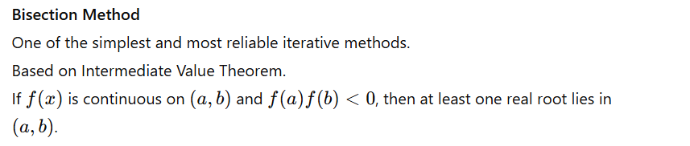

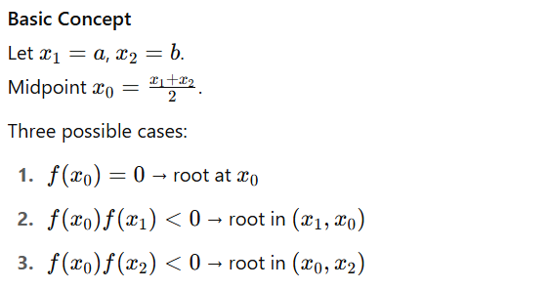

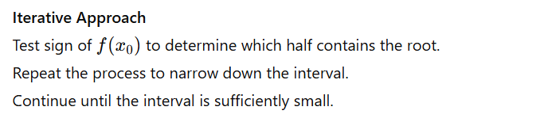

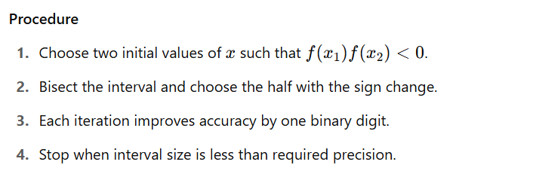

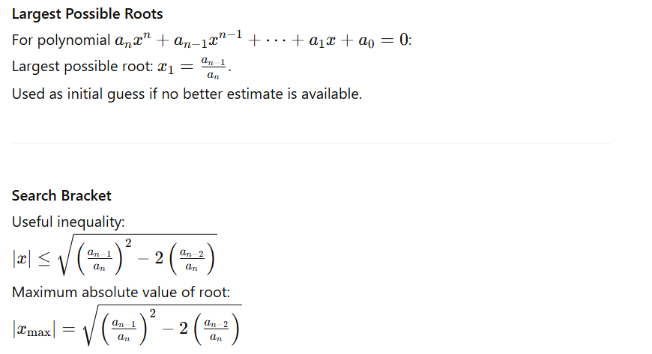

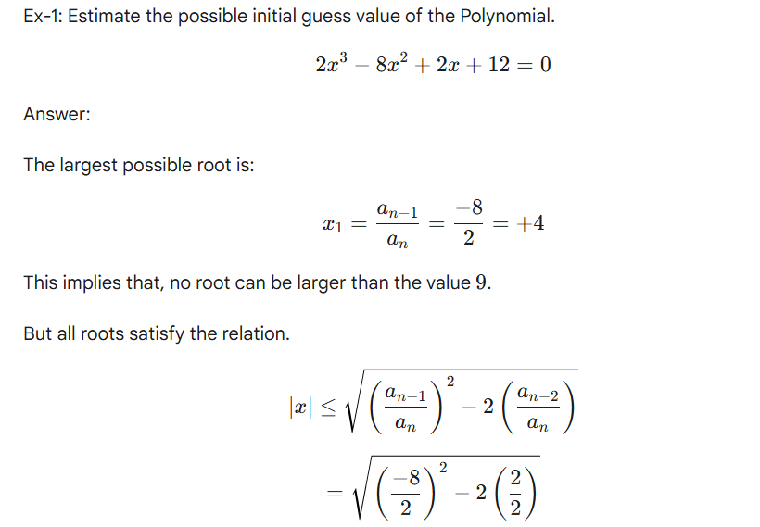



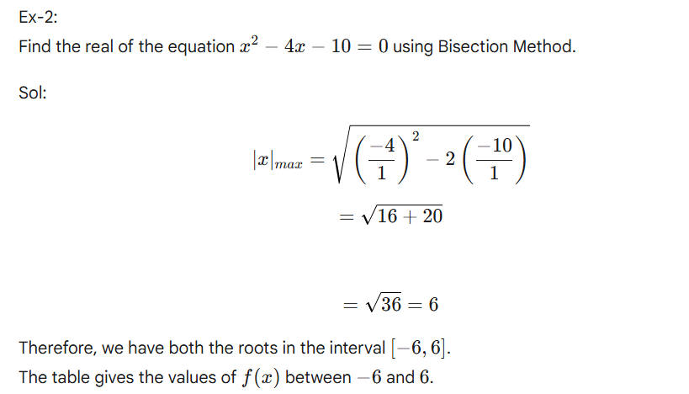

| **x** | **-6** | **-5** | **-4** | **-3** | **-2** | **-1** | **0** | **1** | **2** | **3** | **4** | **5** | **6** |
| --- | --- | --- | --- | --- | --- | --- | --- | --- | --- | --- | --- | --- | --- |
| f(x) | 50 | 35 | 22 | 11 | 2 | -5 | -10 | -13 | -14 | -13 | -10 | -5 | 2 |

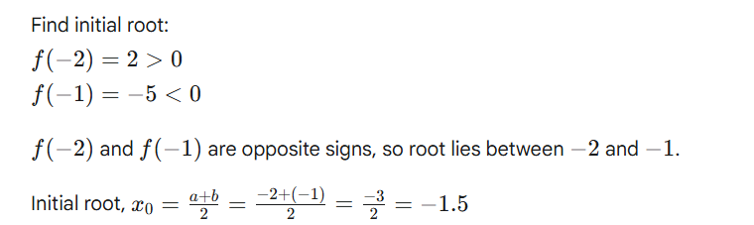

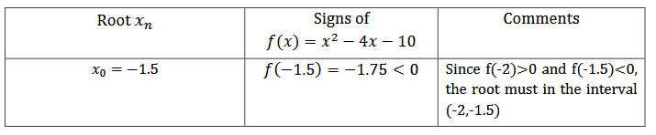

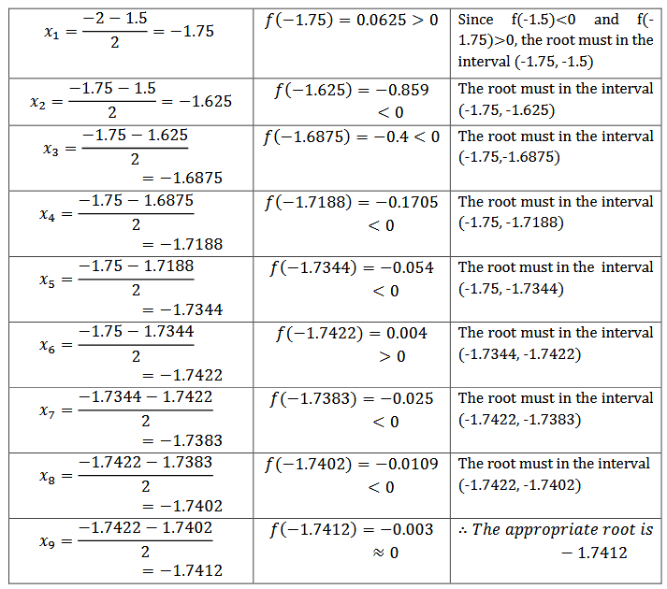

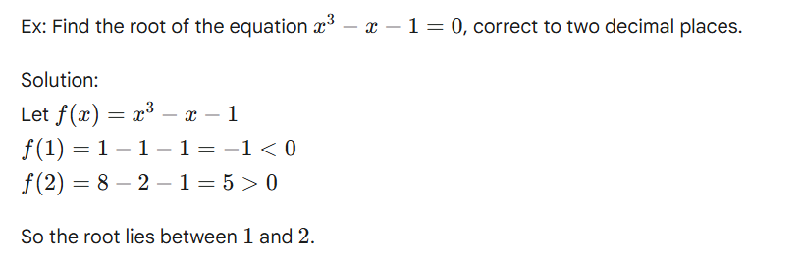

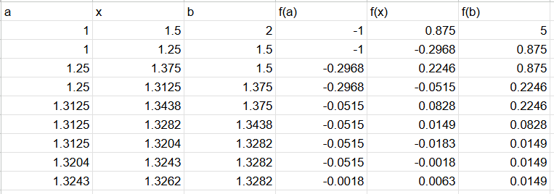

So up to two decimal places the root is 1.32

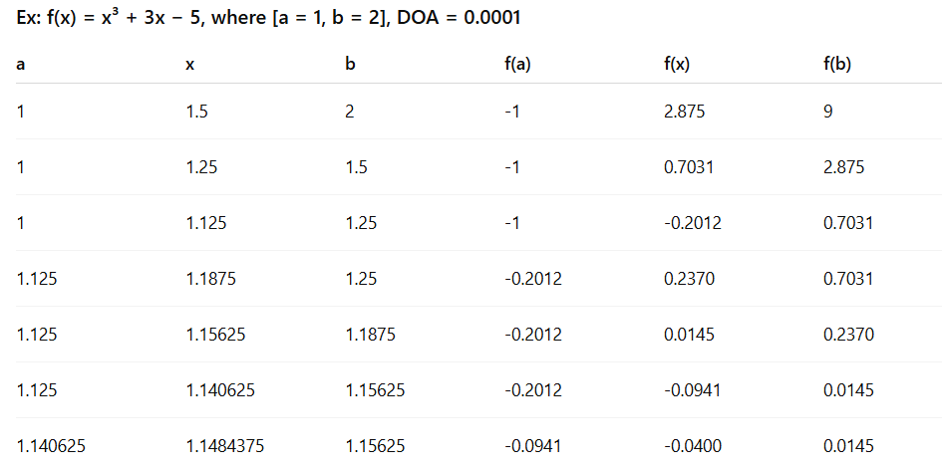



Answer is: 1.154296

Ex: Find the root f(x)=3x+sin(x)−ex=0

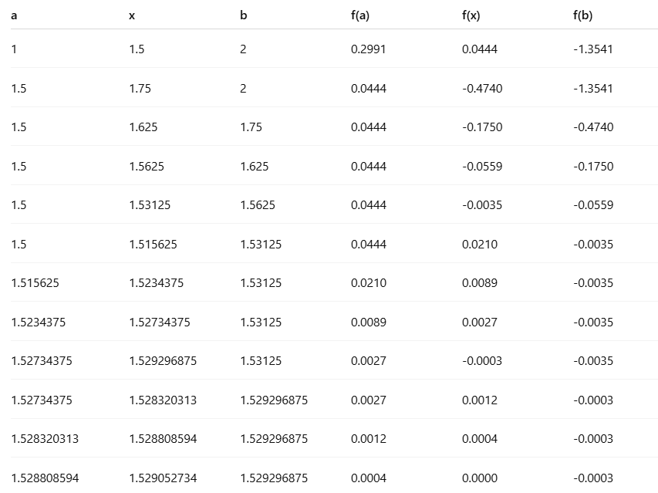

The root is 1.5292966875

Ex: X3 – 7X2 +14X – 6 = 0 on[0,1]

